Lab 1: Motor 1 Efficiency Mapping
Dual-Motor PMSM Dynamometer using the F28069M Host/Target Workflow

Objective
Generate a Motor 1 efficiency map from real dual-motor dyno data. Motor 1 is the speed-controlled drive motor. Motor 2 applies the load through the coupled dyno setup. Students collect four debug signal pairs, save them as trial folders, and run the MATLAB processing script to create raw plots, filter diagnostics, valid operating points, and efficiency maps.
Each of the four trials takes about 6 minutes of total runtime. Not including setup and any reruns, total lab time is set to a minimum of 24-30 minutes.

1. Required Software
Use a fresh installation of MATLAB R2023b or MATLAB R2024a with the required support packages. The lab workflow depends on Simulink model execution, C2000 code generation, and TI hardware deployment.
- MATLAB R2023b or MATLAB R2024a
- Simulink
- Embedded Coder
- MATLAB Coder
- Simulink Coder
- C2000 Microcontroller Blockset
- Motor Control Blockset
- Fixed-Point Designer
- TI Code Composer Studio (CCS)
- C2000Ware
- controlSUITE, if required by the selected MATLAB/C2000 support package workflow
Warning: Follow the software installation order from the course setup document. Installing support packages or third-party tools out of order can cause MATLAB hardware setup or deployment failures.

2. Required Files and Scripts
File / Model | Purpose
Lab_1_Setup.m | Prepares the Motor 1 efficiency-map sweep and opens the host model.
debug_save.m | Saves the selected debug signals into a named trial folder.
data_processing.m | Loads trial01 through trial04 and creates the efficiency-map figures.
Host model | Main interface used to run the motor and select debug signals.
Target model | Built and deployed to the C2000 hardware before running the host model.
Important: All trial folders must be saved directly inside the DMD project folder. Do not save trial folders inside timestamped dyno_session folders for this lab.
C:\CourseDev\DMD\Lab1

3. Run the Setup Script
- Open MATLAB.
- Navigate to the Lab1 folder in the DMD project folder.
- Run Lab_1_Setup.m.
- Confirm that the host model opens.
Lab_1_Setup.m
What this script does: It creates the Motor 1 speed-reference sweep and the Motor 2 dyno-load command used for the efficiency test. It also opens the host model so the experiment can be run from Simulink.

4. Deploy the Target Model and Confirm Serial Setup
Before collecting data, the target model must be deployed to the F28069M hardware and the host-model serial communication ports must be configured correctly.
- From the host model, click the target model link.
- In the target model, click Build, Deploy, and Start in the top-right area of the Simulink window.
- Wait until the build and deployment process finishes.
- Return to the host model after the target model has been loaded onto the hardware.
- If communication does not work, check the COM port in Host Serial Setup, Host Serial Receive, and Host Serial Transmit.
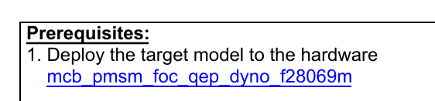
Figure 1: Link to the target model from the host/prerequisite instructions.
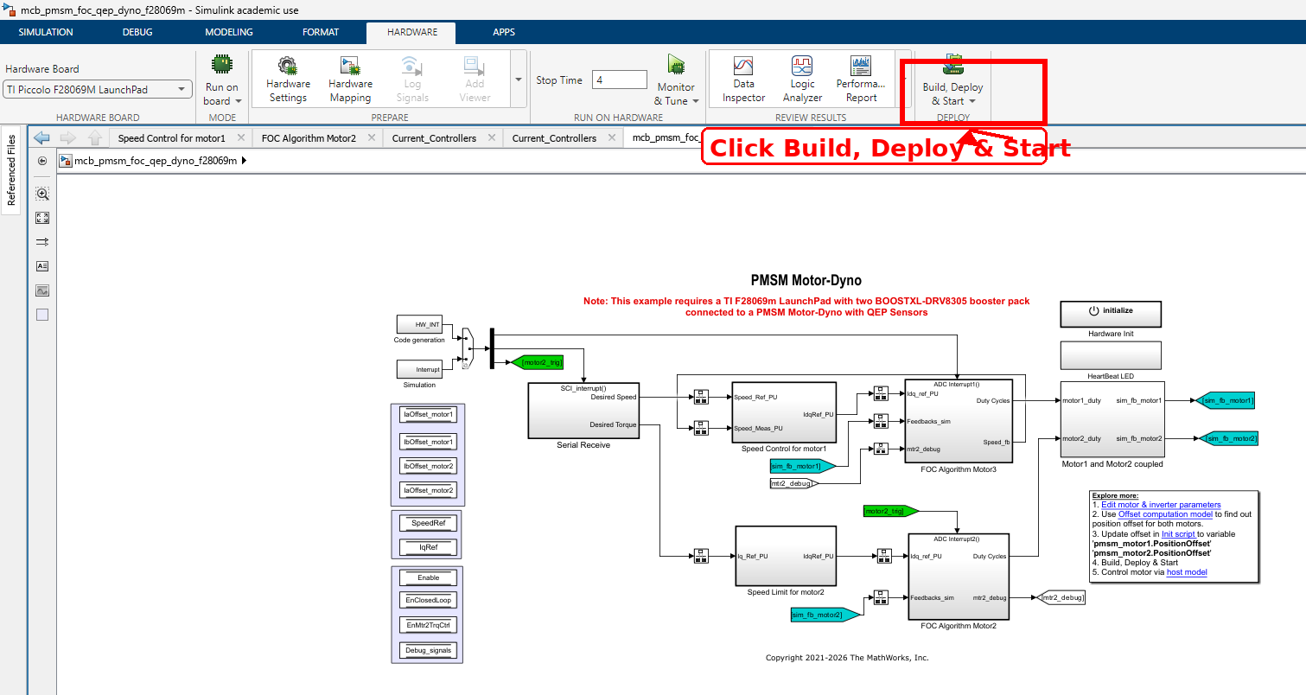
Figure 2: Target model with the Build, Deploy, and Start button annotated in the top-right corner.
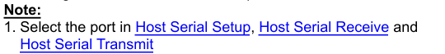
Figure 3: Host serial setup note. Select the correct COM port in Host Serial Setup, Host Serial Receive, and Host Serial Transmit if communication fails.

5. Run the Host Model and Start Motor 1
- In the host model, click Run.
- Use the Motor 1 switch to start the motor.
- Allow the full sweep to run until the motor returns to near-zero speed.
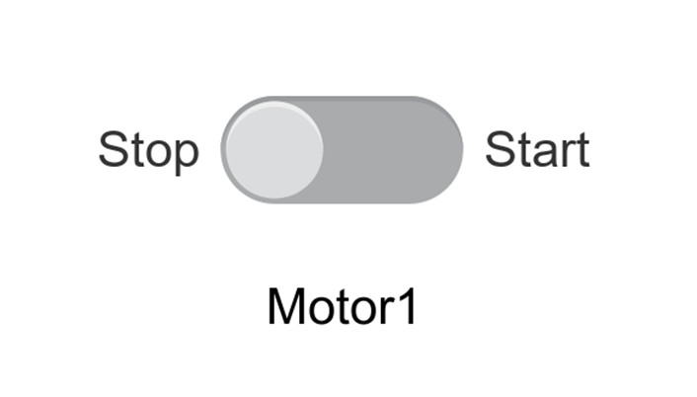
Figure 4: Motor 1 start/stop switch in the host model.
Expected behavior: Motor 1 should accelerate through the programmed speed sweep while Motor 2 applies the load command. The sweep ends when the motor returns close to zero speed.

6. Collect the Four Required Debug Trials
The host model can only save one selected debug signal pair at a time. For this reason, the same experiment is repeated four times. Only the debug selector changes between runs.
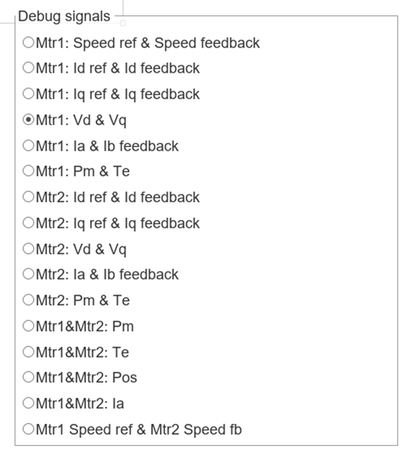
Figure 5: Debug signal selector used to choose the signal pair for each trial.
Trial folder | Debug selector choice | Purpose
trial01 | Mtr1: Speed reference & Speed feedback | Captures commanded and measured Motor 1 speed.
trial02 | Mtr1: Iq reference & Iq feedback | Captures the torque-producing q-axis current command and response.
trial03 | Mtr1: Vd & Vq | Captures the d-axis and q-axis voltage commands. Vd is zero in the Simulink model, so Vq is the useful voltage signal for power estimation.
trial04 | Mtr1: Pm & Te | Captures mechanical power and electromagnetic torque for Motor 1.
Critical rule: Run the exact same sweep for every trial. Do not change the sweep profile, model settings, timing, switches, or command variables between trial01 and trial04.
Tip: You can edit the axis min/max values in the live debug plots to properly view the selected signal during collection. This only changes the viewing scale and does not change the saved data.

7. Save Each Trial with debug_save.m
- After a trial ends and the motor returns to near-zero speed, run debug_save.m in MATLAB.
- When prompted for a folder name, type the correct trial folder name: trial01, trial02, trial03, or trial04.
- Confirm that the folder appears directly inside the DMD folder.
- Repeat this process for all four debug selector choices.
debug_save.m
Correct folder structure after data collection:
DMD/
trial01/
debug_1.csv
debug_2.csv
dyno_session.mat
session_info.txt
README.txt
trial02/
trial03/
trial04/

8. Run data_processing.m
- After all four trial folders have been saved, run data_processing.m.
- The script loads trial01, trial02, trial03, and trial04.
- The script creates raw plots, alignment/cleaning plots, filter masks, valid operating points, measured bins, sample counts, and interpolated efficiency maps.
data_processing.m

9. What the Processing Script Does
Raw data plot: Shows RPM, Iq, Vq, Pm, and Te before final filtering. Plot-only clipping is used so extreme artifacts do not destroy the scale. This does not change the actual data.
Alignment to common time base: The four debug selections are saved in separate runs. To compare them point-by-point, the script interpolates them onto one shared time vector.
Basic sanity filter: Removes non-finite values and obvious values outside the expected hardware range, such as impossible RPM, current, voltage, torque, or power spikes.
Vd handling: Vd is set to zero because the actual Simulink model has Vd at zero for this lab. Vq is the voltage command used for the Motor 1 electrical power estimate.
Physics filter: Keeps only meaningful operating points. Low-load regions are rejected because torque and power are too close to the noise floor, which makes efficiency unreliable.
Measured bin map: Groups accepted points by RPM and torque bins. Each bin reports the median efficiency of the valid points inside that bin.
Interpolated view: Creates a smoother presentation view from the measured bins. This view is useful for reports but must be identified as interpolated.

10. Common Debugs and Troubleshooting
- Target model will not build/deploy: Confirm the hardware board is set to TI Piccolo F28069M LaunchPad. Check that C2000 support packages, CCS, C2000Ware, and required third-party tools are installed.
- Host model runs but motor does not move: Confirm the target model was built/deployed first, the host model is running, the Motor 1 switch is on, and the 24 V supply is powered with correct polarity.
- No serial communication or stale data: Check COM port selection in Host Serial Setup, Host Serial Receive, and Host Serial Transmit. Also confirm SCI transmit/receive timing settings were not changed.
- Wrong signal appears in debug data: Confirm the debug selector choice before each run. The trial order must match the table in Section 6.
- Folders save with timestamped dyno_session names: Use the updated debug_save.m workflow and name the folder exactly trial01, trial02, trial03, or trial04.
- Plots show huge spikes or strange startup behavior: Startup artifacts and transient spikes are expected in raw data. They are shown for transparency and removed by sanity/physics filtering before efficiency mapping.
- Efficiency looks unrealistically high at low torque: Low torque/power is close to the measurement noise floor. The physics filter removes these points because small errors can create large efficiency errors.

11. What the Noise on the Plots Means
The raw data intentionally shows unclean real hardware behavior. This is useful because students can see why filtering is required. The noise and spikes are not hidden; they are identified, filtered, and then excluded from the final operating points.
- Startup and shutdown artifacts occur when the motor is just beginning or ending the run.
- Pm spikes can appear during startup and are not treated as valid steady operating points.
- Low-load torque/current noise is expected because the signals are close to the measurement and calculation noise floor.
- Efficiency is very sensitive when torque or power is small. This is why low-load data is removed before mapping.
- The green kept points in the cleaning overlay show which samples survive the final filter.

12. Figures Generated by data_processing.m
Figure | Output file | What to check
Figure 6 | step0_raw_zoomed.png | Raw RPM, Iq, Vq, Pm, and Te behavior before final filtering.
Figure 7 | step1_cleaning_overlay_no_fake_lines.png | Green kept points overlaid on aligned raw signals.
Figure 8 | step2_filter_masks.png | Pass/fail masks for electrical power, mechanical power, torque, efficiency, and the final combined filter.
Figure 9 | step3_valid_points_efficiency_scatter.png | Final accepted operating points colored by efficiency.
Figure 10 | step4_efficiency_map_measured_bins.png | Measured binned efficiency map.
Figure 11 | step5_count_map.png | Number of samples contributing to each bin.
Figure 12 | step6_efficiency_map_strong_interpolated.png | Interpolated presentation view.
Figure 13 | step7_efficiency_map_contour_strong_interpolated.png | Interpolated contour presentation view.
Important interpretation note: The measured-bin map is the most honest representation of the data. The interpolated maps are presentation views and should not be treated as fully measured data.

13. Deliverables
- Screenshot or exported image of the raw data plot.
- Screenshot or exported image of the aligned data with kept points.
- Screenshot or exported image of the filter mask plot.
- Screenshot or exported image of the valid operating-points scatter plot.
- Screenshot or exported image of the measured efficiency map.
- Screenshot or exported image of the interpolated efficiency map.
- Short written answers to the lab questions.

14. Lab Questions
- Does Motor 1 speed feedback follow the commanded speed sweep? Where is tracking best and where is it worse?
- Why does the valid data appear mostly during the loaded portions of each RPM step?
- Why is low-torque or low-power data removed from the final efficiency calculation?
- What does the sample count map say about confidence in the measured efficiency map?
- What is the difference between the measured efficiency map and the interpolated efficiency map?
- At what general RPM and torque region does Motor 1 appear most efficient?
- Why should the interpolated map not be treated as fully measured data?
- What noise or artifact did the raw data plot show, and how did the processing handle it?
- What would happen if trial folders were saved in the wrong debug order?

Appendix A: Example Output Figures
The following images are example outputs from data_processing.m. They are included so students know what type of results to expect.
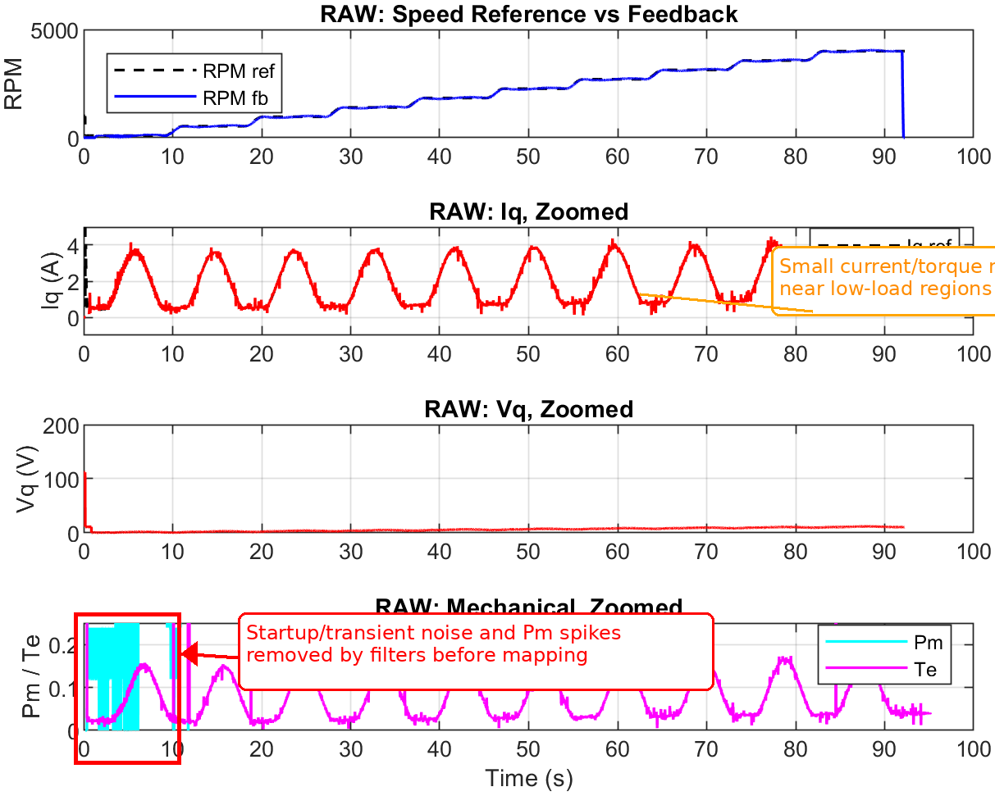
Figure 6: Raw data, zoomed
Raw RPM, Iq, Vq, Pm, and Te behavior before final filtering. The annotation points to startup/transient noise and artifacts that are removed or ignored by the cleaning process.
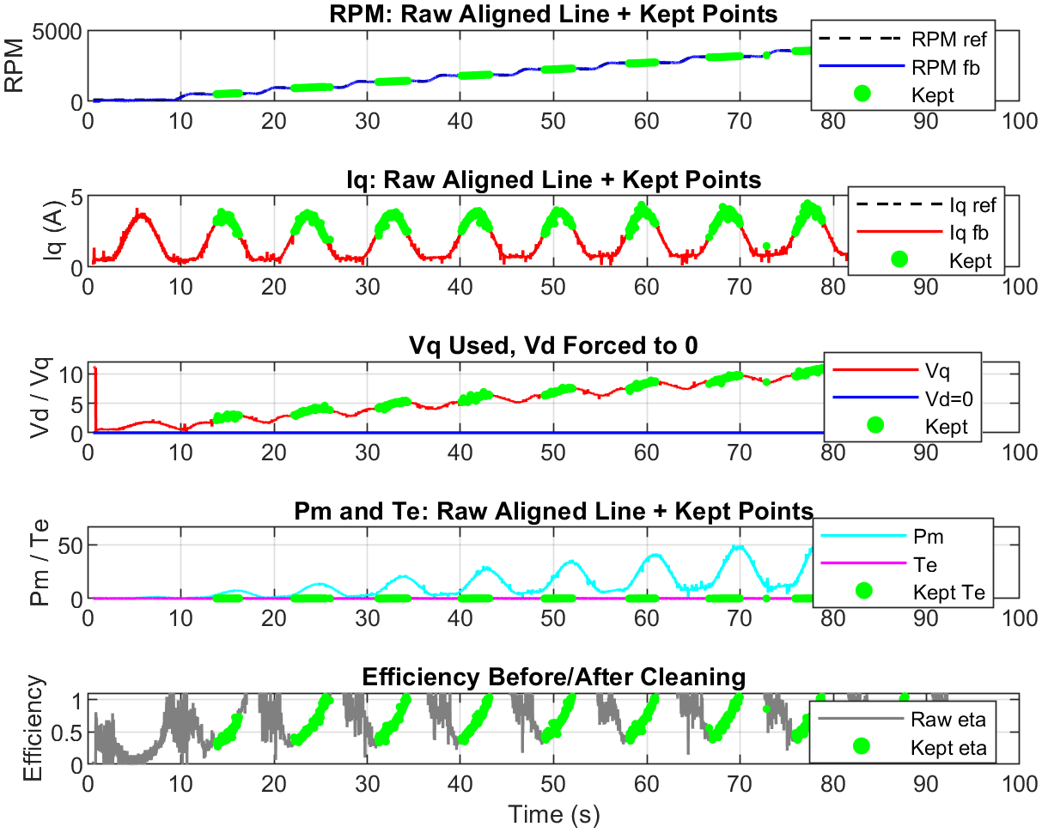
Figure 7: Aligned data with kept points
Green points show samples kept after the final physics filter. Low-load and noisy regions are rejected.
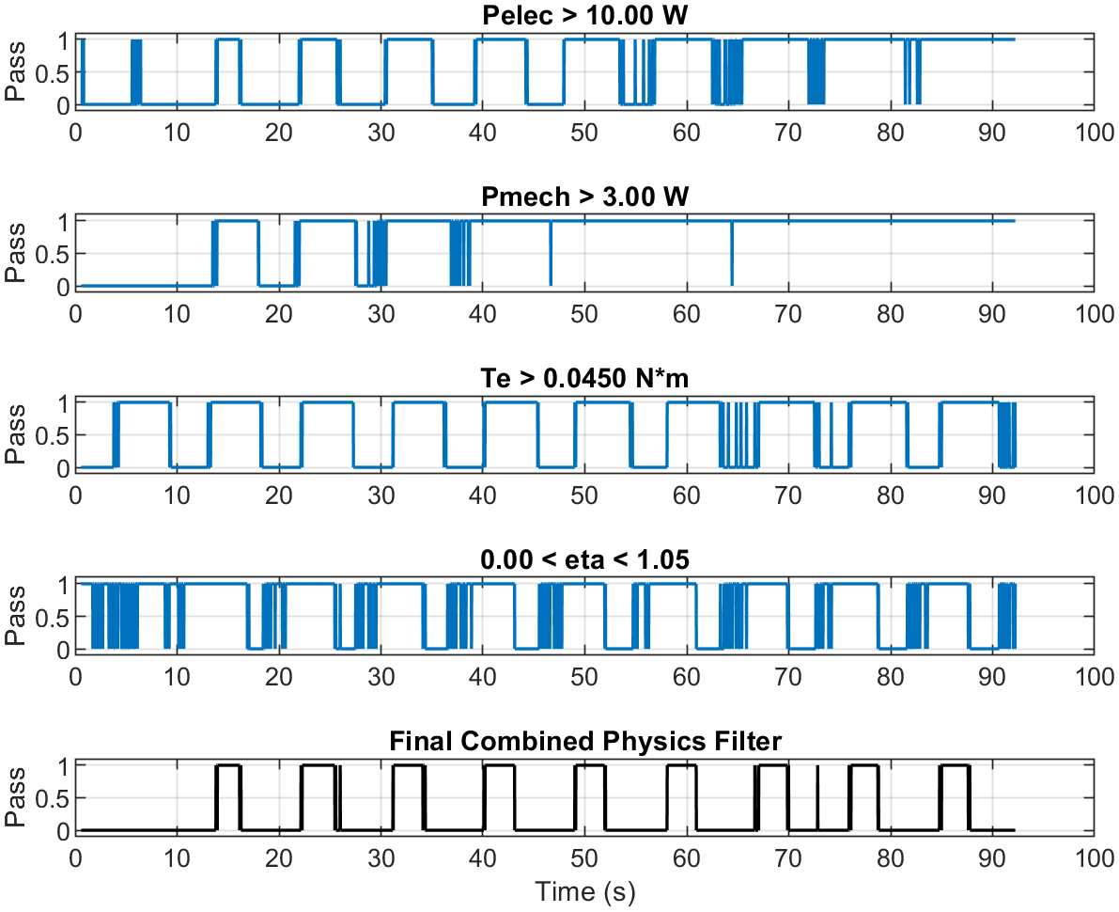
Figure 8: Filter masks
Each row shows one pass/fail rule. The final row is the combined filter used to select valid samples.
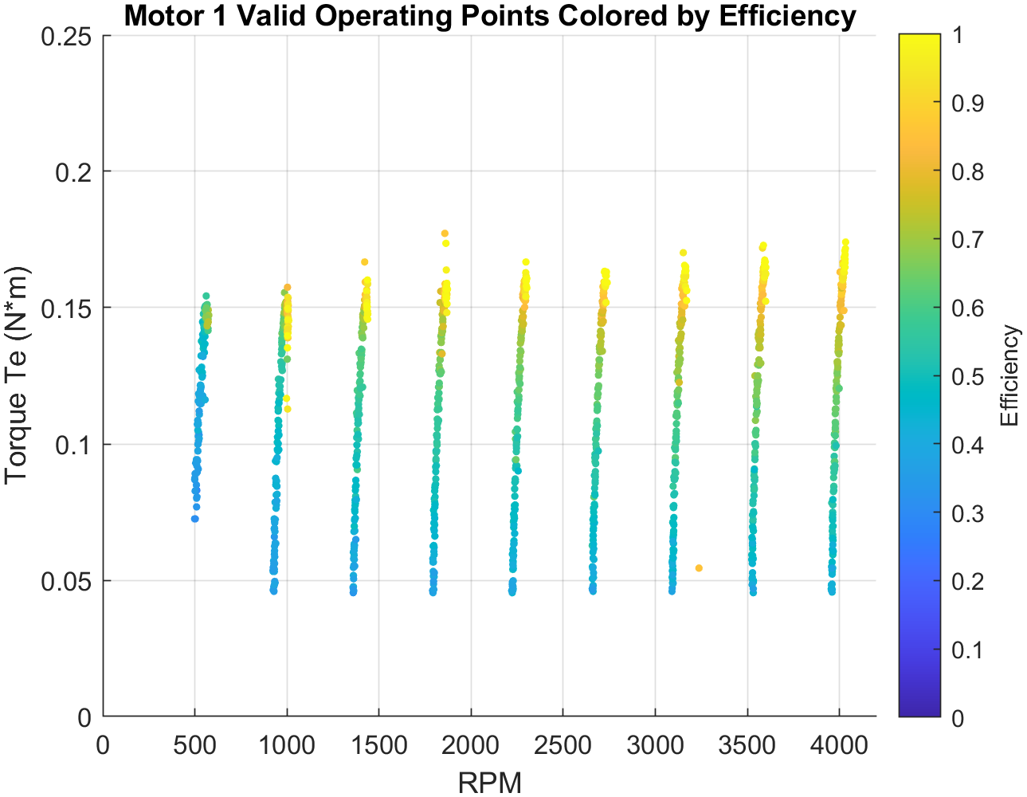
Figure 9: Valid operating points colored by efficiency
Final valid RPM-torque operating points after cleaning, colored by calculated efficiency.
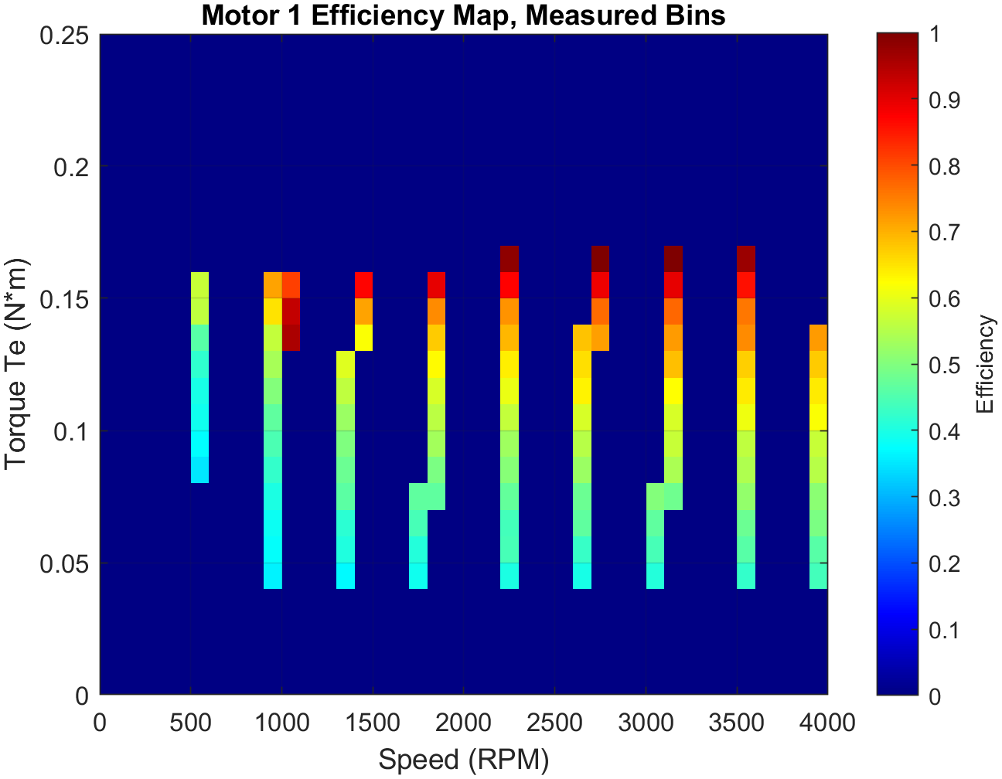
Figure 10: Motor 1 efficiency map, measured bins
Measured-bin efficiency map. This is the most honest representation because only measured bins with enough samples are shown.
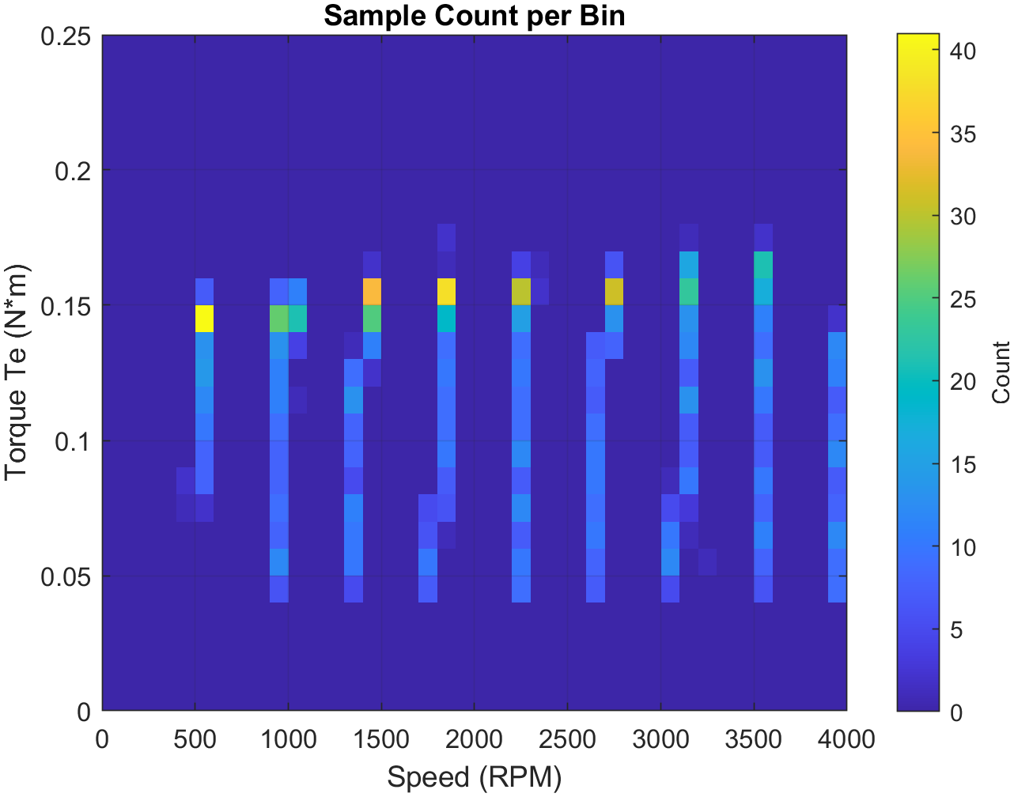
Figure 11: Sample count per bin
Number of samples contributing to each RPM-torque bin. Larger counts indicate higher confidence.
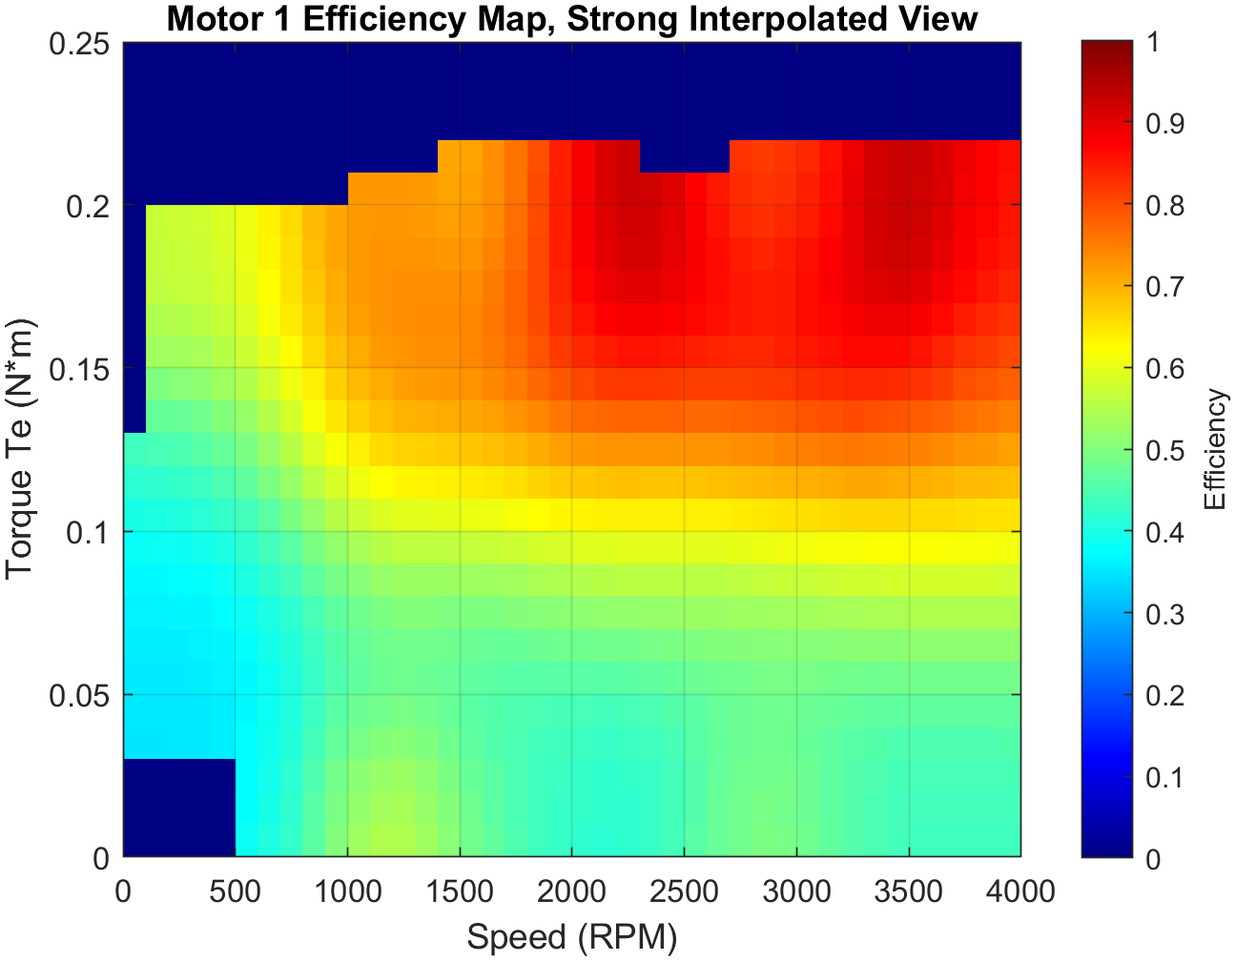
Figure 12: Strong interpolated efficiency map
Interpolated presentation view. This smooths gaps between measured regions and must be labeled as interpolated.
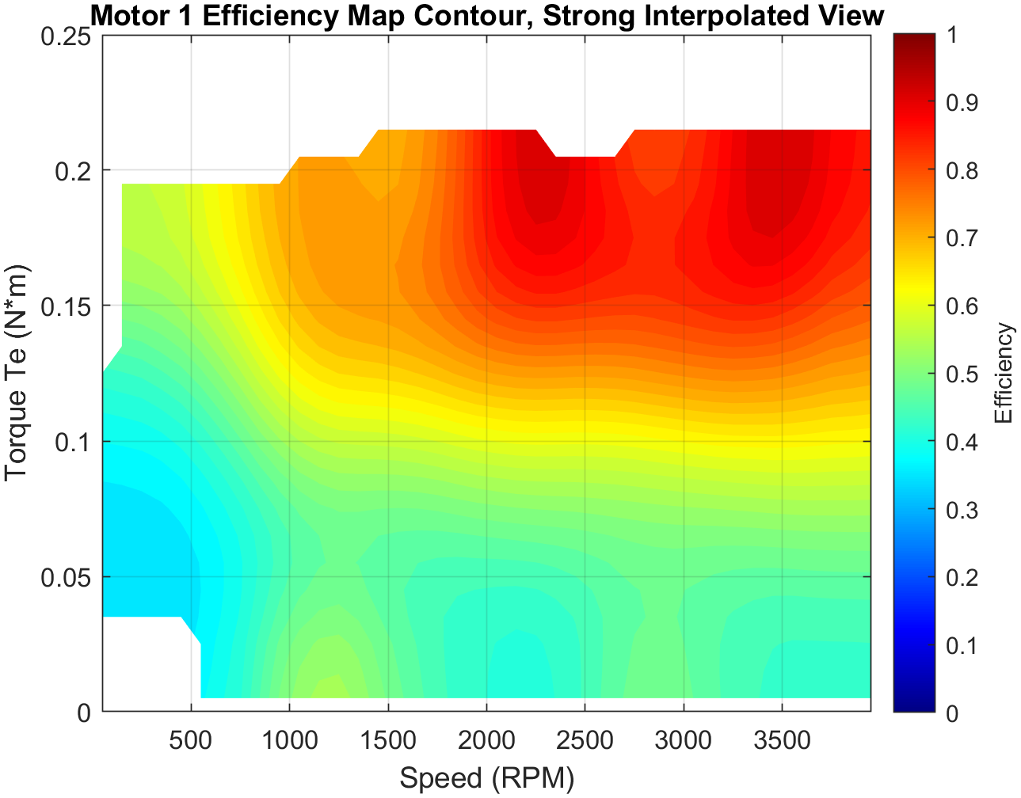
Figure 13: Strong interpolated efficiency contour
Contour version of the interpolated map for presentation and discussion.

